Tending the Flame Workshop - Awakening the Heart of Service
TENDING THE FLAME: A Train the Trainer Workshop for Residency Faculty in Teaching Innovative Self-Care Methods for Strengthening Resiliency & Finding Meaning in Daily Work for Residents
Educators will be trained to offer the Tending the Flame program at their sites.
Using reflection, poetry, symbolism, narrative, art, journaling, generous listening and small-group sharing, Evangeline Andarsio, MD will enable workshop participants to revisit their original calling, discover the personal meaning hidden in their daily routine, and learn self-help methods to reclaim and sustain their passion for their profession.
Details
Where: Salt Fork Lodge and Conference Center
When: 6:00 pm March 24 until 12:30 March 26, 2023
Cost: FREE for ELIGIBLE PARTICIPANTS
Questions? Contact Denise Kropp, BS, BSEd, djkropp@neomed.edu

To Register for one of the offered Training Workshops
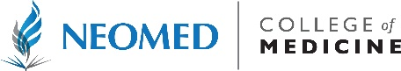
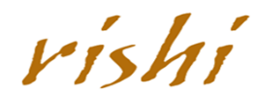
Click HERE Scan the QR Code
